**S3 objects Backup automation using AWS Lambda Function**

**Overview:**

Thereare scenarios when you want to keep a backup of all the files that are being uploaded to a particular S3 bucket to another destination backup bucket automatically when new object are being uploaded to source S3 bucket.

**Tech Stack** – AWS, S3, IAM Roles, Lambda Function, Cloudwatch

**Logic –** Uploading any file as object in S3 will be considered as an **event**. This event will be added as a trigger for Lambda Function. We will be writing the code in lambda function to perform object transfer from source to destination backup S3 bucket. Lambda function will take the event as argument and will fetch the details related to S3 buckets and objects. We will be using boto3 module to create session with AWS resources and perform the required operations. We can view the logs in **CloudWatch** in recent log groups.

**Things to create in AWS:**

**A basic Lambda Function (with python Runtime)**

**An IAM role having read and write access to S3 buckets in AWS to be used for lambda function**

**One source and one destination backup buckets**

**Python code to be used in lambda function as below:**

*import boto3*

*def lambda_handler(event, context):*

*# Define the source and destination S3 bucket names*

*source_bucket_name = 'src-demo-bucket' # Replace with your source bucket name*

*destination_bucket_name = 'destntn-demo-bucket' # Replace with your destination bucket name*

*print(event)*

*s3_client = boto3.client('s3')*

*# Iterate through records in the event*

*for record in event['Records']:*

*# Extract the S3 object key from the event*

*source_object_key = record['s3']['object']['key']*

*print(source_object_key)*

*# Copy the object from the source bucket to the destination bucket*

*try:*

*copy_source = {'Bucket': source_bucket_name, 'Key': source_object_key}*

*destination_object_key = source_object_key # You can modify the destination object key if needed*

*s3_client.copy_object(CopySource=copy_source, Bucket=destination_bucket_name, Key=destination_object_key)*

*print(f'Copied object from {source_bucket_name}/{source_object_key} to {destination_bucket_name}/{destination_object_key}')*

*except Exception as e:*

*print(f'Error copying object: {str(e)}')*

*return {*

*'statusCode': 200,*

*'body': 'Object copy process completed.'*

*}*

**Use below reference Snippets for Handson guide:**

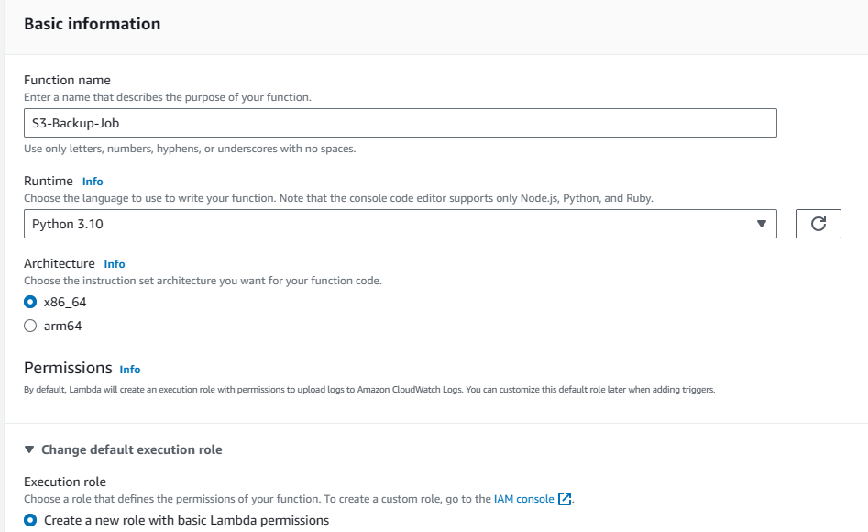

**Lambda Function**

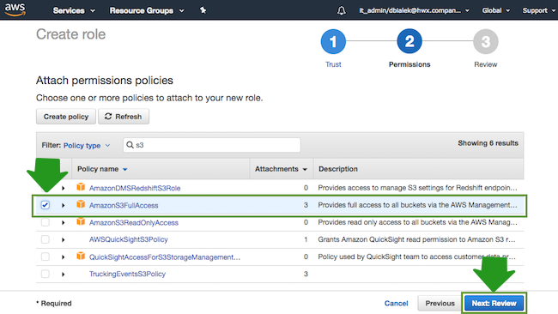

**Attach S3FullAccess policy to Role used for Lambda Function**

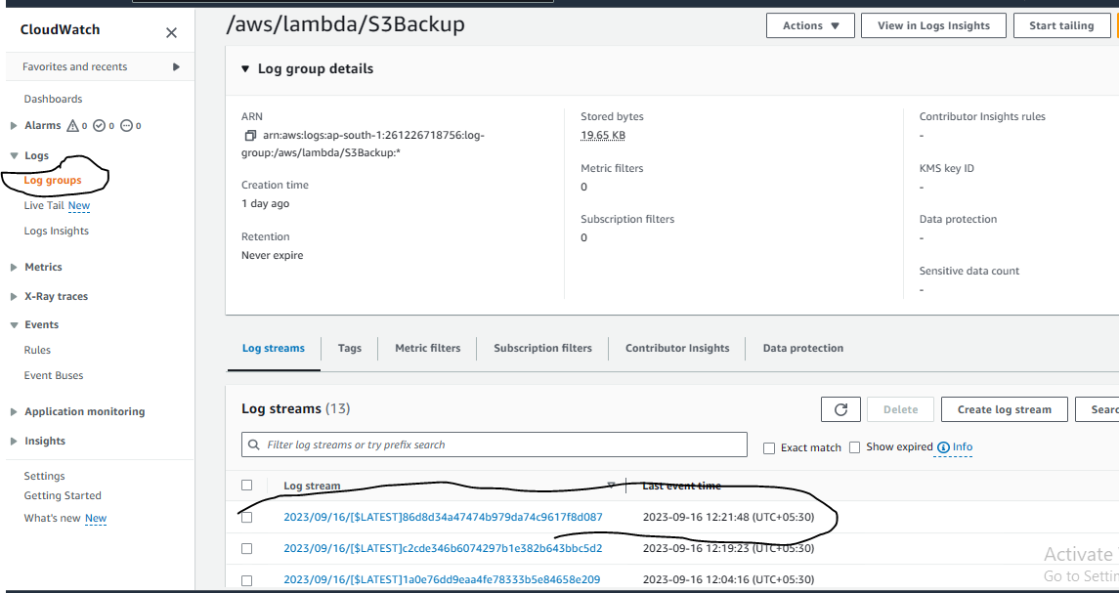

**CloudWatch Log group for log monitoring after uploading sample object in S3**

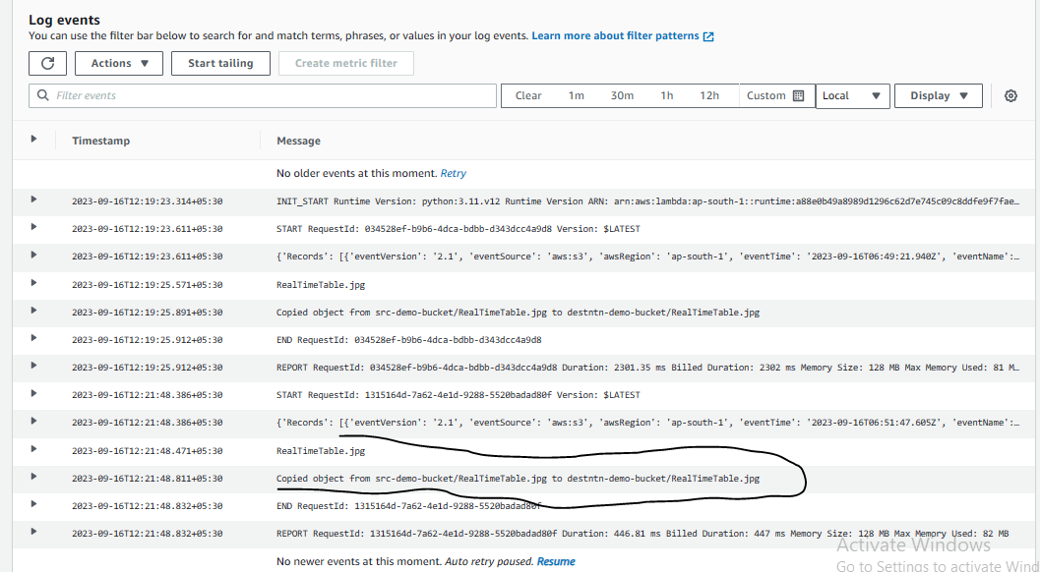

**Viewing logs after uploading object in Source bucket**

**Thank You!!**